Music Logging
NC Folk Festival

About Music Logging
What is music logging? All Folk Festival performances are recorded for the NC Folk Festival and eventually archived in UNCG’s library. Music loggers make and document those recordings so they are ready for archiving. Logging is important work: It preserves festival performances for future generations to study and enjoy.

What’s in This Document?
About Music Logging ......................................... 1
Using the Zoom Recorder .................................... 2
Completing Log Sheets........................................ 3
Keeping Note Sheets.............................................4
Log Sheet Best Practices ..................................... 5
Sample: Poor Log Sheet....................................... 6
Sample: Excellent Log Sheet ............................... 7
At the Festival (Tips for your Shift)......................8

Job #1 of Music Logging: Using the Zoom H4n Pro Recorder
Running the Zoom H4n Pro machine is simple, but it is also Job #1. All the documentation in the world doesn’t matter if the performance doesn’t get recorded. Please read these instructions before you arrive for your shift. If you have problems or questions, call or text a Team Leader. We’ll make sure everything works fine and that you know exactly what to do.
One, Two, Three – For Every Act You See
During a normal shift at our Folk Festival, a logger will see anywhere from two to four acts on his stage. For each act (called a set), you will press three buttons on the Zoom recorder. One, two, three – for every act you see

 | 1. Rec:  Creates a new File | 2. Play/Pause:  Starts Recording | 3. Stop:  Stops Recording
When to press it | Anytime in the minutes before the act goes on | Just before the presenter begins to introduce the act | When the act is done and announcements are complete
What happens | Red light surrounding Rec button blinks | Timer starts moving at top of LCD display | Timer stops
What it means | Recorder is ready for a new show on a new file number | Recorder is working | Recorder has stopped
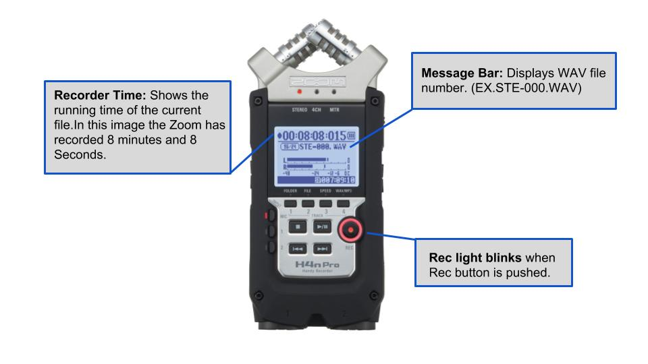
Almost as Important Job # 2: Completing Log Sheets
The Zoom is simple but vital: If we don’t record the show, there’s nothing to archive. Without log sheets, though, the archiving can’t be done. Log Sheets must be clean, complete and legible.
Components of a Log Sheet: The Easy Stuff
A Log Sheet has two parts. The top half lists:  • Group Name/Performance Music Genre  • Stage and Time Set Sound Engineer  • Logger  • Presenter  All the performers and their instruments and vocal participation*  This is theoretically easy. The cheat sheet in our supply bag will include this information—but you’ll need to confirm it. Be proactive: Get backstage before the performance to compile your list, be polite, and ask for help from a manager or artist buddy if you need to. | 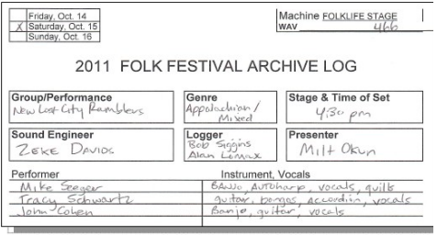

Components of a Log Sheet: Where It Gets Tough
Where the job gets tricky is with the bottom half of the Log Sheet. This is where you list all introductions, spoken parts and songs, as well as start time for each and relevant notes. You should always ask the performers for a set list, but don’t blindly trust it. Bands often change their minds during the show, and they never list song introductions or unexpected encores. It’s your job to capture what really happened.

This is what you want your Log Sheet to look like when all is said and done, but most performances aren’t clear- cut. Because you will always have questions (What was the name of that song? What’s the name of the guy with the weird hair—and what’s he playing, anyway?), it’s impossible to produce an ideal Log Sheet during a performance—which is why we first produce Note Sheets. | 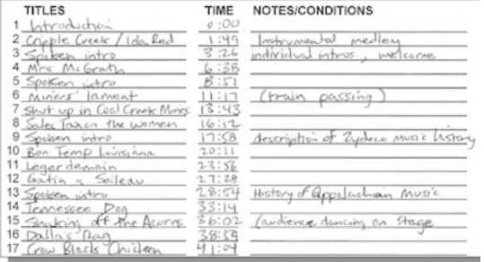

Keeping Note Sheets
Keep a Note Sheet and go back to make a clean, formal Log Sheet only when you are sure you have it right. Log sheets are neater this way, and you can correct times and song names and even to decide to separate a spoken introduction or break up a medley when you realize that makes sense.
Sometimes one logger needs to stay backstage during part or all of the show to take notes. This most often happens with foreign language acts and when the performers can’t or won’t provide a set list. While the sound table logger writes down times, obvious titles, keywords and other notes that help identify a song, the backstage logger takes notes (often with help from a manager or artist friend).
In the sample below, the logger at the soundboard wasn’t sure of the title for the song that started almost 24 minutes into the set, so he wrote 23:56 “...you tricked me once.” The logger backstage was in a position to ask the title (and included some lyrics, since the title didn’t illuminate): Title: Legerdemain Words: ...you tricked me once, you lousy dog... Later, these notes can be compared to put together a clean song list: Legerdemain 23:56
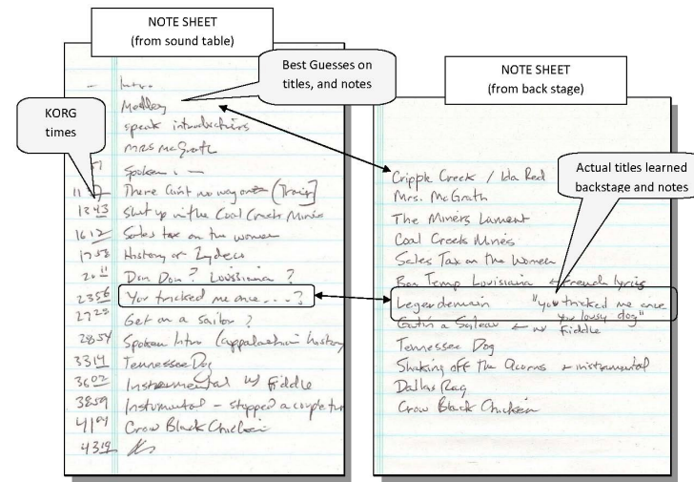

At the end of the performance, the two loggers combine their Note Sheets to create the following ideal Log Sheet.

FINAL LOG SHEET (based on Note Sheets)
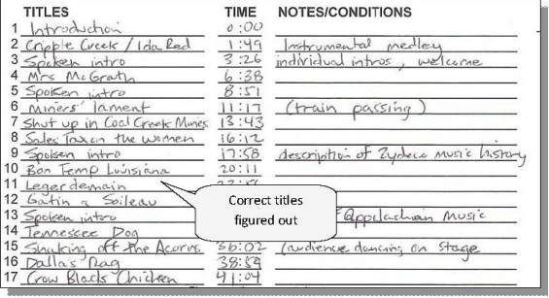
Log Sheet Best Practices
• Label your log sheet completely.
• Make sure the WAV file number is legible and in the correct location on your log sheet.
• In the song list, the first item you list is always the introduction of the act by an emcee. The first real song is therefore the second item on the music log.
• Separate significant spoken song introductions. If they are less than 20 seconds or so, treat them as the beginning of the song. If they are much longer, put them on their own line and call them “Spoken Intro.”
• Take notes about the environment or visual aspects of the show and include them in the comments.
Trains passing (Train passing at 12:15)
Crowd interaction with performers
Unusual instruments, costumes or actions on stage (What was that thumping sound?)
• Medleys: Generally treat these as one song (which happens to have multiple parts). Usually a medley really is a medley: a single, indivisible track that includes several songs. Anybody remember the Beach Boys medley from 1981? One song. If you feel they’re separate songs just played back to back and you can separate them, do so, marking transition times on your log sheet and naming each song. You can note they were played as a medley in the comments. Use your best judgment.
• Unidentified songs: This is rare, but sometimes even if you ask the performers after the show, they’ll say there is simply no name for a song. Do your best to provide a meaningful name. The worst case is calling tracks “Song 1,” “Song 2,” and so on. Try to at least give topical names like “Wedding song” or “Birth celebration dance.”
So what does that perfect Log Sheet look like? First, on the next page, take a look at a poorly done Log Sheet. Page 7 shows that Log Sheet done the right way.
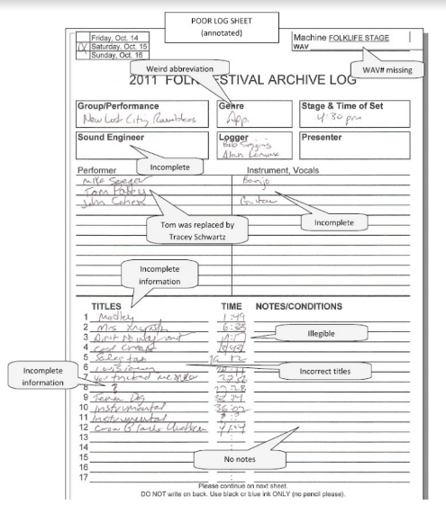
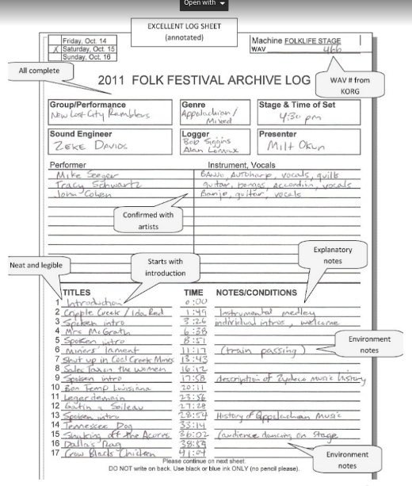

At the Festival
Now that you know how to run the Zoom and are ready to produce fantastic Log Sheets, here are a few final tips:
If you have problems, don’t sweat it! The team leaders are there to help. Call or text (with your name and stage) if you’re missing supplies or the Zoom isn’t working properly. Or if a volunteer doesn’t show up or gets sick, or if you just need some help.

Show Up Ready  • Check in 45 minutes before your shift, at the Volunteer Check-in Tent.  • Call Doug Baker (336) 508-5819 or Wayne Young (336) 253-4472 to notify him of your arrival.  • Report to your assigned location as directed. | Mistakes We See  • Being MIA. Call a Team Leader if you’ll be late.  • Anonymous texting. Include your name and stage.  • Not dressing appropriately. Bring a poncho or a hat to protect you from rain and sun.
At the Stage: Check Your Supplies
• The logger supply bag should contain at least two notepads, several working pens, a clipboard, flashlight, blank Log Sheet, festival schedules, and a logging cheat sheet. Text or call a Team Leader if you’re missing any supplies
At the Stage: Run the Zoom  • Check to see that the Zoom exists when you arrive at the stage. It should be attached to the soundboard.  • Leave the knobs alone. Adjusting the knobs is the sound engineer’s job.  Zoom Malfunctioning? Text or call team leader (include your name and stage location) Keep calling until you get someone! Don’t wait!! | Mistakes We See  • Failing to press each button at the right time, for each set: One, two, three⎯for every act you see.  • Pressing Record too late. Record all the intros.  • Pressing Stop too early. Run the recorder until all encores and ending announcements are complete  • Pressing Record more than once. It’s not a pause button; don’t touch it again during a performance.
At the Stage and Around the Festival
• Because of where we sit, loggers are often the first to see a lost child or dangerous situation. Please be attentive, and use your perch to ensure our festival is safe, fun and welcoming for everyone. The sound engineer can report the need for an urgent message to the emcee backstage.
When Your Shift is Complete
• Be sure you have completed a Log Sheet for each act you’ve logged.
• Call a Team Leader before leaving the stage. Never abandon an active stage with no relief crew. Call us!
• If yours is the last shift of the day, leave your supply bag where it is—unless a Team Leader has asked you to drop it off somewhere.
• Never disconnect the Zoom. The NCFF representative will get it.
• Come back again. This great festival can’t succeed without you. Thank you! We greatly appreciate your time. We hope to see you next year and that you’ll recommend us to your music loving friends.

